Art. No. 341047 - 341026 ECLIPS TWIN QR111
Description:
The ECLIPS is a recessed fixture for double lamps which fits into the range of the ECLIPS fittings. The fixture is easy to install with 4 torsion springs. The frame has an oval shape. The complete body & lamprings are 100% made out of aluminium.
The Fixture exists in 2 finishes; textured white powdercoated & textured black powdercoated..
Installation frames and boxes are also available.

TAL – Essentials collection

Electrical data:
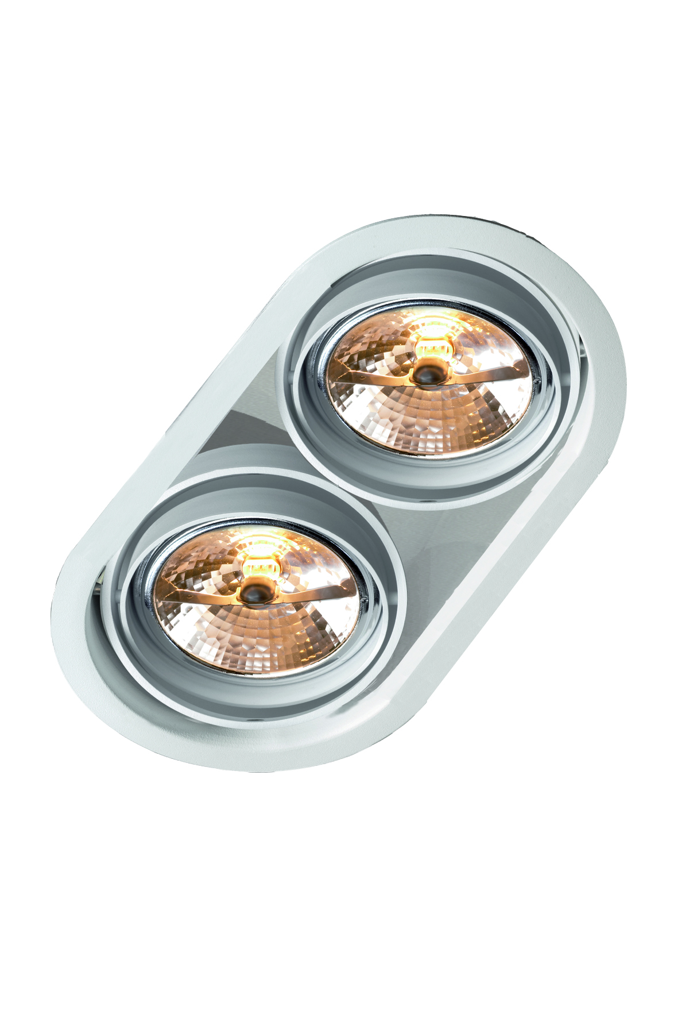
Lamp type: QR111 20-100W
Lamps: 2
Lampholders: G53
Control gear: Remote transfo
Input supply voltage: 12V-50Hz
Connector block: 2x2,5mm²
Glow wire resistance: 960°
IP rating: IP20
Protection classification: 
Mounting surface classification: 
Approvals: 

Materials and finish
Housing and lamprings: 100% Aluminium (AlMgSi0,5) + powdercoated

Installation and lamp replacement:
The luminaire fits into an oval hole into the ceiling and is hold by 4 torsion springs.
Lamp replacement is very easy by just pulling on the lamps (hold by springs), and unscrewing the G53 socket

Technical data
Cut-out: 2X diameter 158 with center distance of 140mm
Installation height : 115mm
Luminaire dimensions: 318X178X115mm
Weight: 2,5 kg
Adjustability: Lamp can be oriented in all directions by gimble system
Accessories: 341077 – Installation Box for plaster
341097 – Installation Box for concrete

